*Market*

CORNER

*Ingredients For Your Success!*

# Poultry

Wings demand has begun to pick up as we enter football season but

# Pork

Butts both Bone-in and boneless materials are

[**SCAN OR CLICK HERE**](https://syys.co/3Muk8b2)

[**TO VISIT OUR MARKET CORNER**](https://syys.co/3Muk8b2)

**Published:** September 13, 2024

*Market*

HEADLINES

there is availability. Tenders continue to be mostly steady. Jumbo breasts are seeing some extra availability. Medium and small breasts continue to stay steady. Dark meat demand remains very good. Whole birds are mostly balanced.

# Beef

PRIME and upper 2/3rd graded product is limited. Ribs and tenders continue to hold pricing relatively steady to higher. As for the loin complex, struggles continue in the Ch and Sel arenas and buyers are hesitant to commit. The chuck and round complexes continue to perform well overall. Grinds continue to struggle to clean up inventories due to underwhelming demand.

# Grains / Oil

Soybean oil futures finished the week slightly down vs. the previous week. The weaker energy markets and some technical data appear to be the driving reasons for the decline. Stats Canada released its data for Canola, and the expected yield has increased for seed. Palm oil moved lower last week after several weeks of higher moves.

supported, with increased pulled pork interest. Loins are steady in the bone-in sector, while boneless are mixed due to some export demand. Ribs are mixed across types. Bellies remain unsettled as supply and demand is mixed. Trim markets 72’s are steady and 42’s have weaker supply.

# Dairy

Shell egg markets are down this week. California and Northwest markets are down. The Block & Barrel are increasing. U.S. cheese exports in July were up 10.1% YoY. Butter is down, after hitting new record highs in the middle of last week, EEX butter futures pulled back a bit.

# Seafood

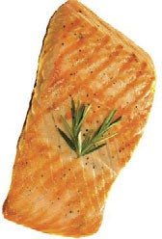Commodity groundfish market continuing to firm up due to raw material availability. Prices of imported shrimp are also increasing

due to import cost increases that are affecting all items coming into the country in containers. Container availability is causing the most recent incremental increase.

# Soy Bean Oil

**Beef**

USA is importing beef at elevated levels this year; at just over 2.6 billion pounds, a +20% increase year to date through the end of July.

# Seafood

A typhoon recently hit the southern part of China, where suppliers of tilapia facilities and farms are located. We are in communication with our Portico tilapia suppliers to assess the situation and any possible supply disruptions.

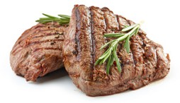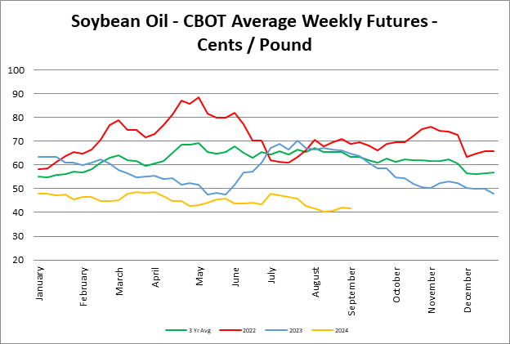

**To learn more contact your local Sales Consultant.** Market Corner Produce information reflects both

U.S. and Canadian markets. All other commodity information is based on U.S. market data only.

*Market* CORNER

**Published:** September 13, 2024

# Asparagus



Demand exceeds as regional shift in both Peru and Mexico has caused limited supplies. All sizing affected. . Filling orders will be challenging through September.

# Avocado

Field prices remain relatively stable. U.S. market prices are falling on large fruit due to lower demand but are expected to rise on small fruit over the next two weeks as supplies are more limited. California will have inventory for the next 2-3 weeks.

# Bell Peppers

East - green bell supply better, quality good, demand good, market steady. Red and yellow extremely limited. West - Supplies are steady on all varieties, although larger sizing green is still limited. Market is lower on red and yellow. Quality is fair with pack outs heavy to choice.

# Broccoli

Market a little softer on decent supplies but expect demand to pick up as local deals start to wind down. Some quality issues noted at the field level due to the recent heat.

# Cauliflower

Market is lower after two weeks of very light supplies. Volume is still snug but should meet the demand. Quality is improving.

# Celery

Market mostly steady on all sizes as supplies continue to meet the demand. Quality is reported as good.

# Cilantro/Parsley

The markets are mostly steady on both cilantro and parsley with moderate to good supplies and demand.

# Grapes

Grape quality is good to very good. Some volume lost due to extreme heat over a 3- week period of time, but those effects will be felt more in October and November with an expected earlier than normal finish to the California crop. Market steady.

# Hot House

LE Cucumber continue to transition to winter plantings and demand exceeds supplies.

# Citrus

Lemons- Market is steady on 165 ct and smaller, 75 and 95 ct are up slightly. Decent volume from California and the additional fruit coming in from Chile.

Oranges -Valencia quality is a challenge as the crop is coming to an end. Expect lighter volume on Chilean navels the next 2 weeks and pick back up week of 9/23. Imported fruit is starting to size up. Quality is good.

Limes - The market continues to escalate with overall availability declining. Overall pack-out yields of adequate-quality fruit have decreased to approximately 20-30%. On-and-off rain this week is impacting harvest/packing. Quality fair.

# Lettuce Iceberg

Markets are a little lower as supplies and quality are expected to be good into next week.

# Lettuce Romaine

Supplies and quality good, with some higher seeder reported. Market steady on both romaine and romaine hearts.

# Onions

Demand is good with good volume and quality during the harvest of yellows reds and whites in Washington and Oregon. The market is expected to remain steady for the time being.

# Potatoes- Russets

Supplies are improving as the harvest gets under way. Quality is good aside from minor skinning which is typical at the start of harvest. Sizing is better than we saw last year. Prices are lower on 40-70 ct and higher on smaller sizes.

# Tomatoes

Markets continue to stabilize both east and west for all varieties (round, roma, grape, & cherry). Quality continues to improve as volume increases.

# Squash

East - zucchini supplies good, demand good, quality very good, and market little lower. Yellow squash is limited, quality good, and market stronger. West Moderate supplies both zucchini and yellow.

PRODUCE MARKET

*Updates*

# Green Onion

Limited supplies of green onions from Mexico continue. The market is creeping higher as supplies struggle to meet demand. Growers are doing their best to mitigate quality issues from the previous heat in the growing regions at the field level.

# Blueberries

Supplies are very limited from all suppliers due to weather-related quality issues bringing the Pacific Northwest region to an abrupt end. Peru has started with much lighter volume than normal due to past weather and crop issues.